Power Transformer

1. What is a Power Transformer?
A Power Transformer is a mathematical transformation used to make data more normally distributed (Gaussian). It reduces skewness and stabilizes the variance of features.
It is mainly used before applying machine learning algorithms that assume the data follows a normal distribution.

Why do we use it?
Many ML algorithms perform better when features are normally distributed, such as:
- Linear Regression
- Logistic Regression
- Linear Discriminant Analysis (LDA)
- Gaussian Naive Bayes
Power Transformer helps improve the performance of these models.

Types of Power Transformations

1. Box-Cox Transformation
- Works only on positive values (> 0).
- Cannot handle 0 or negative values.
- Finds the best power (λ) to transform data into a normal distribution.
Formula:
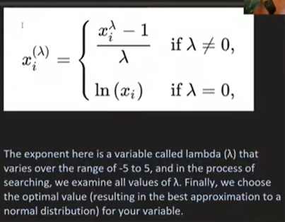

Restrictions
- Positive numbers only
- No zeros
- No negative values

2. Yeo-Johnson Transformation

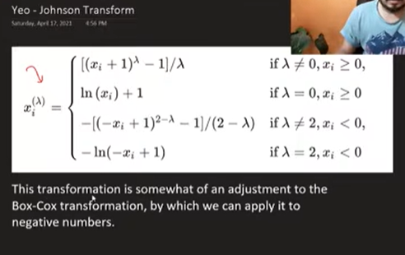
- Modified version of Box-Cox.
- Works with:
  - Positive numbers
  - Zero
  - Negative numbers
This is the default method in Scikit-learn.

Lambda (λ)
Lambda is the power used for transformation.
Examples:
- λ = 1 → No transformation
- λ = 0 → Log Transformation
- λ = 0.5 → Square Root Transformation
- λ = 2 → Square Transformation
The algorithm automatically chooses the best λ that makes the feature as close to a normal distribution as possible.

Scikit-learn Implementation
Import:
from sklearn.preprocessing import PowerTransformer

Box-Cox
pt = PowerTransformer(method='box-cox')
X_new = pt.fit_transform(X)

Yeo-Johnson (Default)
pt = PowerTransformer()
X_new = pt.fit_transform(X)
or
pt = PowerTransformer(method='yeo-johnson')

Finding Lambda Values
pt = PowerTransformer()

X_new = pt.fit_transform(X)

print(pt.lambdas_)
Each feature gets its own λ value.

Example Workflow
from sklearn.preprocessing import PowerTransformer
from sklearn.linear_model import LinearRegression
from sklearn.model_selection import train_test_split

X_train,X_test,y_train,y_test = train_test_split(X,y,test_size=0.2)

pt = PowerTransformer()

X_train = pt.fit_transform(X_train)
X_test = pt.transform(X_test)

model = LinearRegression()

model.fit(X_train,y_train)

Advantages
- Makes data more normally distributed.
- Reduces skewness.
- Stabilizes variance.
- Improves the performance of many ML algorithms.
- Automatically selects the best λ value.

Disadvantages

Box-Cox
- Cannot handle zero values.
- Cannot handle negative values.

Yeo-Johnson
- Slightly more complex than Box-Cox.
- May not improve every dataset.

Practical Example
Without Power Transformer:
Linear Regression Accuracy (R²)
≈ 0.62
After applying Box-Cox:
≈ 0.64
After applying Yeo-Johnson:
≈ 0.66
(Actual values depend on the dataset.)

Box-Cox vs Yeo-Johnson
Feature | Box-Cox | Yeo-Johnson
Positive values | ✅ | ✅
Zero values | ❌ | ✅
Negative values | ❌ | ✅
Automatically finds λ | ✅ | ✅
Default in Scikit-learn | ❌ | ✅

Exam Points
- Power Transformer is used to make data approximately normally distributed.
- It reduces skewness and stabilizes variance.
- There are two methods:
  - Box-Cox (positive values only)
  - Yeo-Johnson (positive, zero, and negative values)
- Scikit-learn class:
from sklearn.preprocessing import PowerTransformer
- Default method:
PowerTransformer()
uses Yeo-Johnson.
- The best λ (lambda) is selected automatically for each feature.
- Apply fit_transform() on the training data and transform() on the test data.

